Release Notes – DSCC 3.74 (Build 722)

What has changed from 3.74.0721?

Fix: Gaging menu bar precision toggle button - now displays correct value (ActiveX special function page)

When host applications directly jumped to a special gaging function page (page 220), the displayed text of the precision toggle button was wrong.

This fix enhances the fix done in 3.74.0721 but in this case the page is not directly navigable via DSCC’s menu bar. It is only visible when ActiveX control is used and the module’s special function page 220 was jumped directly to.

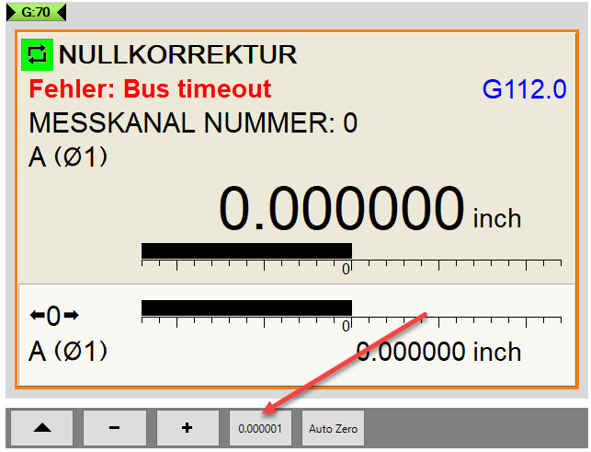

Basic settings parameter  “Unit in display” | Button text  (multiplier disabled state) | Button text  (multiplier enabled state)
0.0000 mm | 0.0001 (was already ok) | 0.001 (was already ok)
0.00000 inch | 0.0001 (old, wrong)  0.00001 (new) | 0.001 (old, wrong)  0.0001 (new)
0.000000 inch | 0.0001 (old, wrong)  0.000001 (new) | 0.001 (old, wrong)  0.00001 (new)

