Release Notes – DSCC 3.74 (Build 720)

What has changed from 3.73.0719?

First version that supports DS6000UP devices

This is the first DSCC release that supports DS6000UP devices. Changes have been made to DeviceConfigurator so that DS6000UP devices can be configured next to DS6000 devices (IP address, baud rate, …) and also firmware updates are possible with the help of the DeviceConfigurator tool.

Further, module type is correctly detected in DSCC.

Updated logo in info dialog and log file

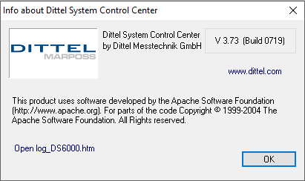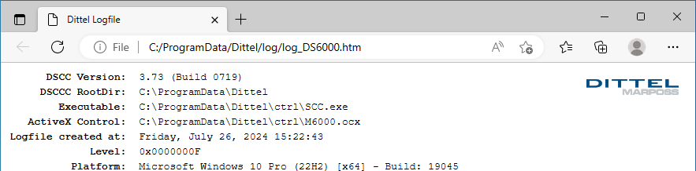

before

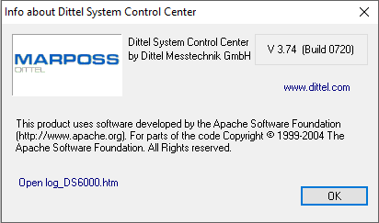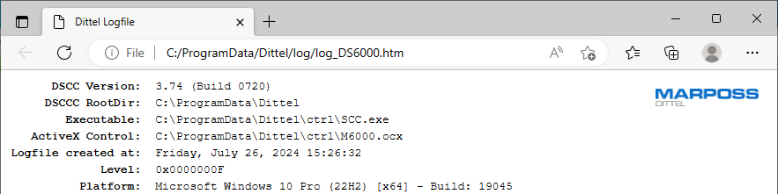

after

